Food in prison
Unit 2
Rules and requests

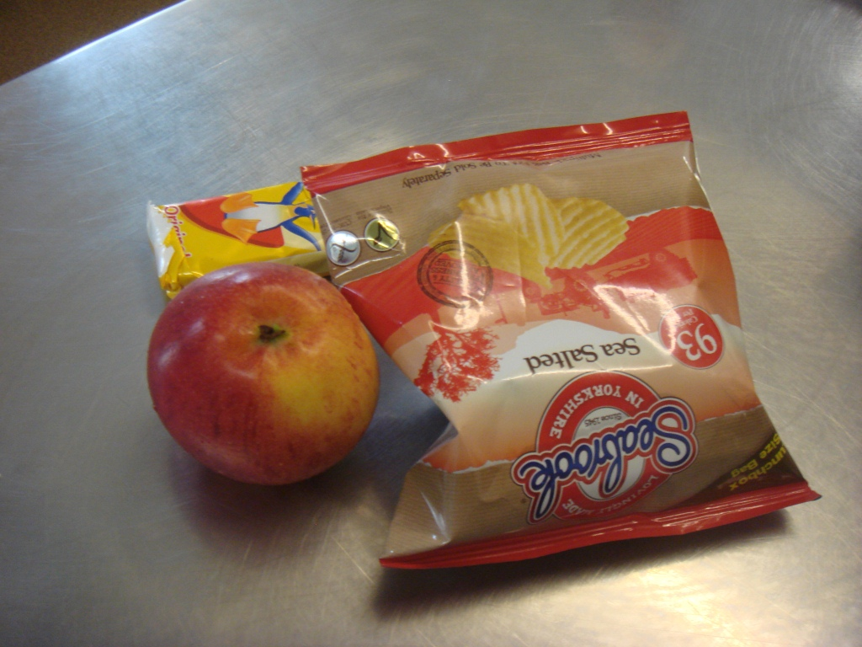

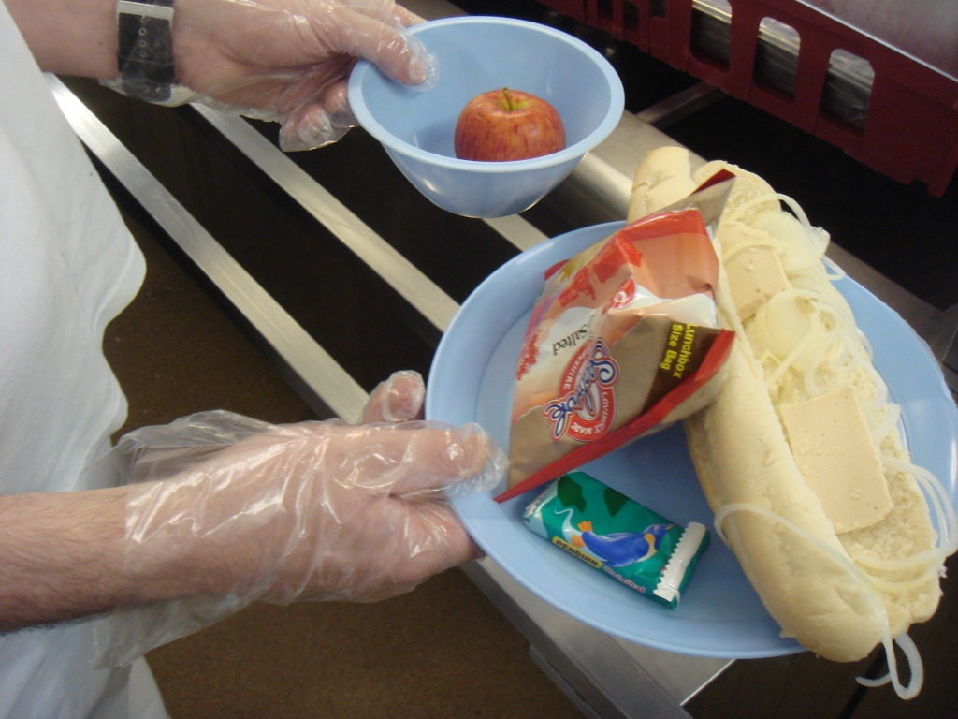

Contents

Unit 2 Eating in prison teachers’ notes

Unit 2 Eating in prison learner resources

Unit 2 Eating in prison additional resources

Unit 2 Eating in prison answers and transcript

Unit 2 Audio file: TP_FoodBuyinginPrison1_Unit2.mp3

Copyright - please read
All the materials on these pages are free for you to download and copy for educational use only in your establishment. You may not redistribute, sell or place these materials on any other website without written permission from the British Council. If you have any questions about the use of these materials please email us at: esolnexus@britishcouncil.org

Unit 2 Eating in Prison - Rules and Requests: Teacher’s Notes
This unit is designed to help learners identify the language of rules based around the topic of food and eating. The unit provides activities which assist learners in understanding and following basic instructions which they may come across when they first arrive in prison. The unit also covers the topic of asking for help, which some prisoners may find difficult. The procedures in prisons for ordering and buying items are often complicated and this unit provides an opportunity for ESOL learners to address concerns in a learning context. The texts are adapted from a prison induction leaflet and menu.
You will also find activities on asking for help in Unit 1 of Teacher’s Pack: Legal matters.
Time – approximately 125 minutes
Aims
- Understand rules and instructions using the imperative form.
- Understand expression of necessity or obligation using ‘have to’ to and the negative ‘don’t have to’.
- Understand expression of permission and obligation using modal forms ‘must/ mustn’t’.
Objectives
Learners will be able to:
- understand meaning of modal forms
- understand some prison rules and relevant vocabulary
- read a set of rules to follow in the dining hall
- make requests for help using appropriate language forms.

Higher level learners will be able to:
- write a set of rules to follow in the dining hall
- write a letter requesting help.

Preparation
You will need
- Resource 1: images of forbidden objects – to display on white board or large copy
- Resource 2: cut out word cards – 1 class set and one per small group of learners for revision
- resource 3a and 3b: 1 copy of 3a per low level learner and 3b for higher levels
- Resource 4a and 4b: 1 copy of 4a per low level learner and 4b for higher levels
- Resource 5: 1 copy per low level learner (differentiation)
- Resource 6a: copy to display or 1 large copy and 1 copy cut up for the class
- Resource 6b: 1 copy per pair of low level leaners (differentiation)
- Resource 7: images of officer stripes, to display/ project or 1 large copy
- Resource 8: audio file TP_FoodBuyinginPrison1_Unit2.mp3
- Resource 9: listening activity, one for each learner
- Resource 10: 1 copy of audio script for each learner (extension)
- Resource 11: 1 copy of canteen sheet per learner
- Resource 12: cut out copies of speech bubbles – allow 4 per learner
- Blank cards about A5 size for pre-entry differentiation
Suggested Procedure
Warmer (5 minutes)
- Display pictures (resource 1) of mobile phone, chewing gum, scissors, glue.
- Elicit what they are and the fact that none of these items are allowed in prisons.
- Elicit ‘can’t have them’ and ask learners to identify which of these and other things they are not allowed in prison.
- Explain the first part of session is about rules – things you must/ mustn’t do.
Activity 1: Pre-reading task (10 minutes)
- Put learners in two groups of mixed levels and ask them to stand in two lines.
- Hand out vocabulary cards from resource 2 to the learners in group 1 and hand out the matching definition cards to group 2.
- Ask learners to match the vocab cards to the definitions by working as a team. Allow them to use dictionaries if need be, but don’t intervene until they have had a few minutes to do this.
- Ask those with words to stand next to those with definitions when they are finished.
- To check, ask the learners to read their words and definitions out. Correct pronunciation of words and drill.
Extension
Ask the learners in their pairs to write a sentence using the word and read it out to the class.

Activity 2: Reading and comprehension task (15 minutes)
- Group learners according to ability level and hand out resource 3a or b.
- Ask learners to scan quickly to pick out one rule and tell their partner. Give them 30 seconds to do this.
- Nominate 2 or 3 learners to say the rules they have found. Choose a mix of abilities.
- Model the activity by reading the statement 1 (under the text) on resource 3a and eliciting the correct answer then ask learners to complete the activity in pairs.
- Elicit and display correct answers.
Differentiation
- For literacy learners, once the other learners are working on the task, work with the group to read out the text or nominate more confident learners to read a sentence or two out loud while those listening read. Support learners to find the correct answers.
- Stronger learners (who only have the text) should write 4 rules from the text using must or mustn’t.
- Pre-entry learners: elicit some rules the learners know about in the prison and turn them into simple sentences using must and mustn’t. Drill the learners then write them on blank cards. If they are able to write, you could write a model for them to copy. Then read their sentences together as a group.

Activity 3: Identify modal forms (15 minutes)
- Ask learners to locate and underline the target words must/ mustn’t and have to and don’t have to in the text.
You have to means something is necessary
You don’t have to means something isn’t necessary
Teach use of don’t + infinitive without to: Don’t throw packets out of your window.

Tip: unless your learners are all high level, do not worry about the difference in meaning between have to and must. The difference is very subtle and could detract from this task.

- Hand out resource 4a and ask learners to answer the questions then check in pairs.
- Feedback correct answers to whole class.
Differentiation
- Pre-entry learners: once the other learners are doing the activity, get learners to read the cards written for activity 2 as a group then in pairs.
- Give higher level learners resource 4b to complete the true/ false activity. Model the first sentence to make sure they understand. When they have finished ask them to tell their partners the correct answers to false ones.
- Higher level learners could paraphrase some of the points made in the text.
Activity 4: Has to/ doesn’t have to (15 minutes)
- At this point revise 3rd person singular has to and the negative doesn’t have to. Explain to learners they are going to look at the role of catering managers and identify what they do.
- Write the following verbs on the board or choose verbs more relevant to your prison:
check open drive get ready take cook prepare tidy up clean.
- Ask learners to work in pairs and, using the verbs, create a list of things they think a catering manager has to do/ doesn’t have to do.
Differentiation/ Extension
- Give low level learners Resource 5 to use images to write sentences starting ‘He/ she has to…’ ‘He/ she doesn’t have to...’
- Ask early finishers to add to the list or create one for another member of catering staff has or doesn’t have to do.
Activity 5: Making Rules (20 minutes)
- Explain to the learners that they are going to make a poster of rules to put in the dining hall.
- Display Resource 6a, drill the words and elicit a model example with must/ mustn’t e.g. ‘You must return all trays to the counter.’
- Hand out one word card to each learner who has to make up a rule using the word on the card. A variation on this is to ask them to say the rule without the word, and the rest of the group have to guess the word on the card.
- Give learners a large sheet of paper or card. Support learners to make a poster of rules to follow in the dining hall using target language. Those who are not confident writing, or those who enjoy drawing, could add illustrations.
- If possible, display posters in the dining hall. Ask the catering manager at your prison
Differentiation
- For lower level learners or those who can’t think of ideas: Resource 6b provides a matching activity to assist with collocation.
Activity 6: Requests – asking for help (5 minutes)
- Elicit who learners approached for help when they first arrived. Was it a neighbour on the wing or a member of staff? Who do they feel more comfortable asking and why?
Suggested discussion questions:
  - Who did you speak to when you first arrived?
  - Did you know anyone?
  - Did you have any problems when you first arrived?
  - Who would you ask if you had a problem when you first arrived, a neighbour or an officer?
- Display resource 7. Ask learners what the differences stripes on the shoulders mean.
Tip: before this lesson, find out what the various officers in your prison’s roles are.

- You could give a copy per pair of learners and ask them to write down the title of each officer according to their stripes. Add officers’ names if appropriate.
- Ask if they know the name of their SO or PO and how to contact them. Elicit titles of other senior officials in the prison – education manager, deputy education manager, head of security, etc. if helpful.
Activity 7: Listening for gist (15 minutes)
- Put the learners into groups according to their levels. Explain you are going to play an audio about someone who has a problem with the pre-select menu. Elicit ideas for what the problem might be.
- Play resource 8 (audio file TP_FoodBuyinginPrison1_Unit2.mp3). Check to see if they identified the problem: she needs help to fill the canteen sheet in.
- Display the gist true/ false questions from resource 9 and play the audio.
- Ask learners to compare their answers.
- Play again to allow them to check then nominate learners to feedback correct answers.
- Hand out a copy of resource 9 and focus on the comprehension questions. Ask the learners if they heard the answer to any of the questions? Get them to work in pairs to answer or guess the answer to the questions.
- Play the audio until you hear the answer to the first question then elicit the correct answer.
- Play the audio through and ask learners to check their answers against what they hear.
- Feedback correct answers to all questions.
Differentiation/ extension
- For lower level learners, play the audio more times.
- For higher level learners, ask learners to answer both the true/ false questions and the subsequent questions at the same time. They should also need to hear the audio fewer times.
- For those who finish more quickly, hand out the transcript to the whole class (resource 10). Ask learners to underline examples of ‘have / need to. ’ Elicit general examples for the negative ‘don’t have to’, for example: ‘I don’t have to get up early on Sunday.’

Activity 8: Speaking – ordering food from the canteen sheet (15 minutes)
- Display symbols, such as V for vegetarian, from resource 11 or draw on the board and elicit what they mean.
- Hand out resource 11 and elicit language you could use to order food from the menu e.g. ‘I’d (I would) like ....for lunch and ............for dinner’.
- Model the task a couple of times with a confident learner and drill learners after you and your partner have said one line.
- Ask learners to work in pairs with one learner ordering from the menu and the other marking the menu accordingly.
- Learners should then swap roles and do the dialogue again. They could swap with another learner and role play again.
Differentiation
- Higher level learners might not need the modelling and drilling stage.
- Learners could report to the group what their partner ordered, using past simple.
- Stretch and challenge stronger learners to ask questions about the food on the menu, for example: ‘What flavour are the crisps? What is the fruit today?’

Cooler (10 minutes)
- Put the class into teams to play back to the board using new vocabulary learnt during the lesson. Put learners in two teams. One learner from both teams should sit at the front. Write or draw a new vocab item on the board and the team should give clues to the person with their back to the board without saying the word in question.

Extension activity: Writing to request help or give information
- Elicit what other things they might need to buy and the procedure for buying them, e.g. buying from the canteen or buying clothes. Encourage them to use modals, e.g.: ‘You have to fill in an app.’ ‘You must put the form in the canteen box.’
- Explain to the learners that they are going to write a conversation helping a new arrival to buy/ order something.
- Give 4 speech bubbles to each learner (resource 12): one learner has question bubbles and the other has response bubbles. Learners work in pairs to create a conversation that using language to ask for things politely.
Differentiation
- Revise vocabulary ‘Can you help me/ tell me how to ...?’ ‘You have to…’ ‘You must... ’ Model the activity first.
- Learners can use the transcript to help them.
- Literacy learners can do the activity as an oral exercise.
Extensions
- Learners can role play their conversation to the class.
- The bubbles can be arranged on a large sheet to make a conversation chart to display.

Resource 1







Resource 2: Definitions
advance | early
pre select | choose something before you need it
return | give something back
issue | give
post | put in a box like a letter
details | information
following | the next

Resource 3a Read these rules from a prison induction leaflet
You have to order your meals in advance.
We give you a Pre Select Menu on Friday to fill in. You must give it back on Monday.
On Friday, Saturday and Sunday you have to collect a snack pack from the dining hall at lunchtime. You will get a sandwich on the wings at 16.45.
We give you canteen sheets on Tuesday. You must return them by Wednesday morning. You have to post your canteen sheet in a canteen box on the wings. Don’t give your sheet to the wing officer.
At meal times you must go to the dining hall when your wing is called.
After your evening meal you must pick up your breakfast pack from the dining hall. You have your breakfast in your room the next morning.
Must or mustn’t? Choose must or mustn’t to fill in the gap
- You _________________ order your meals in advance. must / mustn’t

- You _________________ fill in a Pre-Select menu. must / mustn’t

- You __________________ eat your breakfast in the dining hall. must / mustn’t

- On Friday evening you ______________ go to the dining hall. must / mustn’t

- You _________________ give your canteen sheet to the wing officer. must / mustn’t

- You _______________ pick up your breakfast after your evening meal. must / mustn’t

Resource 3b Read these rules from a prison induction leaflet.

At this prison you have to order your meals in advance. You fill out a Pre Select Menu which is given to you on Friday and must be returned on Monday.
On Friday, Saturday and Sunday there is early lock up so you have to collect a snack pack from the dining hall at lunchtime and a sandwich will be taken to the wings at about 16.45.
Canteen sheets are issued on a Tuesday and must be returned by Wednesday morning. You have to post your canteen sheet in the canteen box which is on all the wings. Don’t hand your sheet to the wing officer.
Details of meal times are on notices on the wings. You must go to the dining hall when your wing is called.
After your evening meal you must pick up your breakfast pack from the dining hall. You have your breakfast in your room the following morning.

Resource 4a: Read the text and answer the questions


- When do you get the pre select menu?

- Where do you collect the snack pack from?

- What must you return on Wednesday?

- Where is the canteen box?

- What must you do after your evening meal?

Resource 4b: Write true or false beside each sentence.



- You have to give back your pre select menu on Friday.

- You have to go back to your cell early on Tuesday.

- You must collect your snack pack from the kitchen.

- Canteen sheets are handed out on Tuesday.

- You must give the canteen sheets to the wing officer on Wednesday.

- You must ask the wing officer for information about meal times.

Resource 5
Match the words below to the pictures and then write your sentences.
clean the windows use a computer have meetings
wash up cook make phone calls



a b

c d


e f



Resource 6a
Make a poster of rules for the dining hall using some of these words

make | return | clear
eat | run | put
smoke | clean | leave

Resource 6b Writing rules

You are now going to make a poster of rules for the dining hall. Match the words on the left with the phrases on the right and use these in your poster.

- make | - trays to the counter
- return | - your table
- clear | - in the dining area
- eat | - in public areas
- don’t smoke | - sure the floor is clean
- don’t run | - up spillages
- clean | - leftovers in the bins
- put | - the dining area quietly
- leave | - when you get to your table

Resource 7

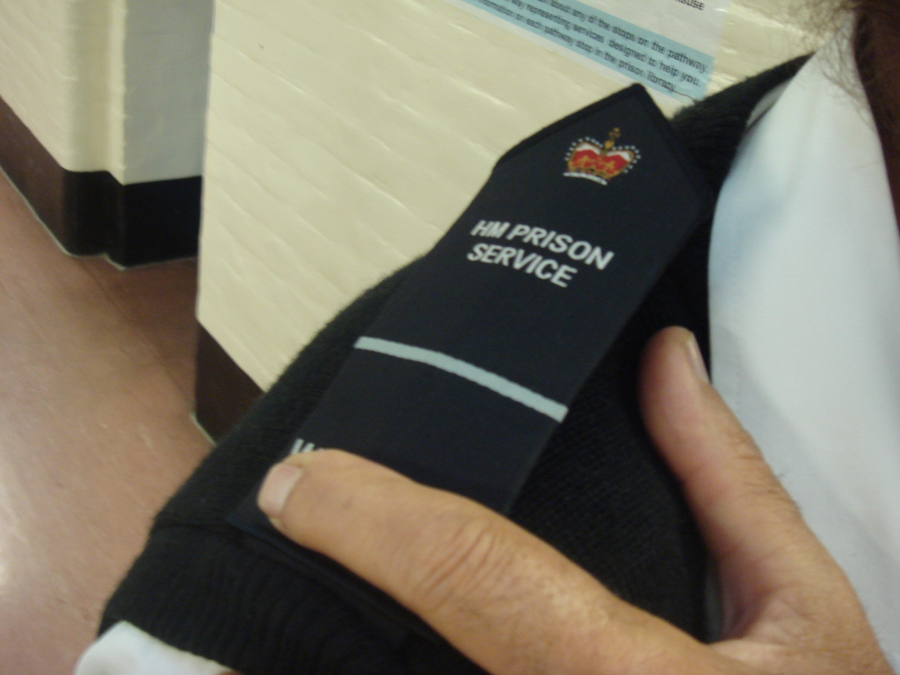 __________________________________

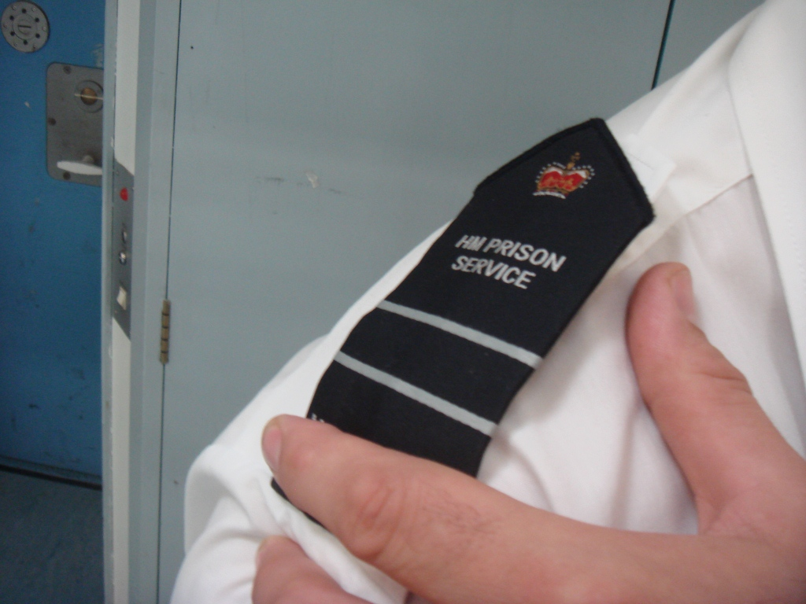 ___________________________________

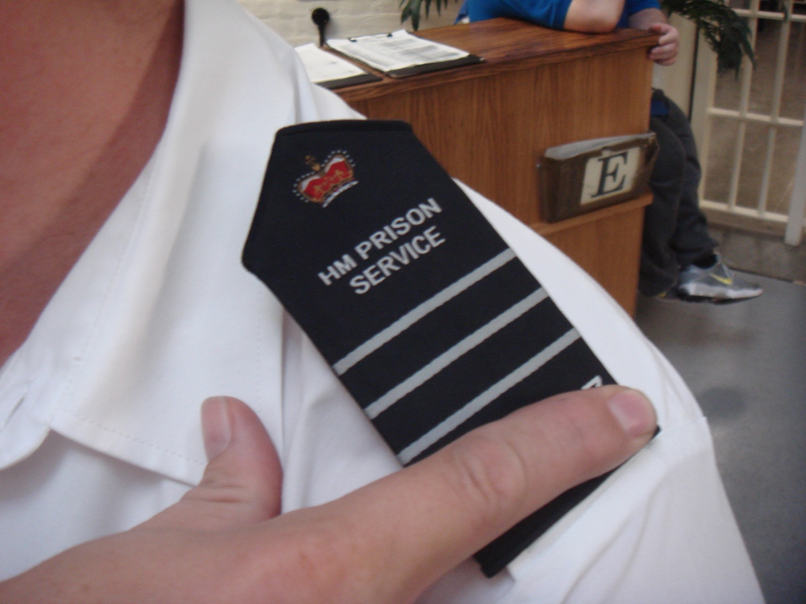___________________________

Resource 9: Listen to the audio

Answer true or false
- He wants to order from the canteen sheet.
- The people talking are teachers.
Now listen again and answer the questions
- When is the menu put under the door?

- What tells you about the food?

- What does V mean?

- Which symbol means vegan?

- What don’t vegetarians eat?

- When do you have to hand in the form?







Resource 10: Talking about Food
A: All right? I’m new here. Can you tell me how I order food from the menu?

B: Oh, yeah sure, you’ve got the menu right? It’s put under your door on Friday.

A: Yeah, I’ve got it here, but I don’t understand what I have to do.

B: OK. The pictures just tell you about the food, so if you’re a vegetarian...

A: Yeah I am.

B: Well, you look for the V on the list. On this menu, you can see that there is a V next to vegetarian lasagne and salad.

A: Oh, I get it. So I just look for the letter V...for vegetarian.

B: Yeah. But you can also eat vegan food, right?

A: Yeah. It’s just that vegans don’t eat eggs or milk or cheese either but vegetarians eat them. Just as long as it doesn’t have meat in it, I’m OK.

B: Right, well there’s a flower next to vegan food, so you’re looking for Vs or flowers…look for the V for vegetarian or the flower picture for vegan. Then here on the form, on the right – you need to put a line there to show that that’s what you want.

A: Cheers for that.

B: You have to hand the form in on Monday, or you won’t get anything!

Resource 11
Key
 = halal  = fish  = vegan V = vegetarian  = pork 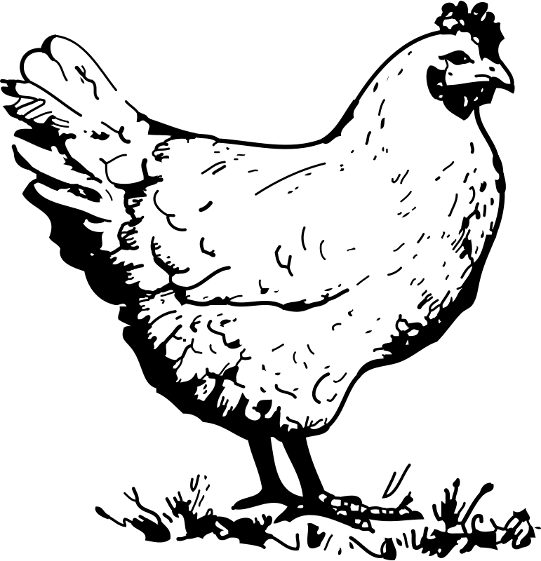 = chicken
 = healthy = beef

Lunch
Choice A Tuna and Onion Sandwich   [ ]
Choice B Vegan sausage dog  V [ ] Choice C Egg Mayo Sandwich  V [ ]
Choice D Ham and mustard sandwich  [ ]
Choice E Halal Turkey Burger in a Bun  [ ]
+ Packet of Crisps [ ] + Fresh Fruit  [ ]

Dinner
Choice A Beef Lasagne with salad  [ ]
Choice B Vegetarian lasagne + salad  V [ ]
Choice C Roast Beef and Yorkshire Pudding  [ ]
Choice D Salmon Fishcakes and Salad  [ ]
Choice E Halal Sweet and Sour Chicken  [ ]
Sweet
Choice F Apple crumble and custard [ ]
Choice H Fresh Fruit  [ ]

Additional Resource 12


Unit 2 Eating in Prison – Rules and Requests Answer Sheet
Resource 3a – prison induction leaflet
- must
- must
- mustn’t
- mustn’t
- mustn’t
- must

Resource 4a – answer the questions about the leaflet
- Friday
- Dining hall
- Canteen sheets
- On the wings
- Pick up your breakfast pack
Resource 4b – true/ false about the leaflet
- Falls
- False
- False
- True
- False
- False
Resource 5 - differentiation
- He has to cook.
- He has to make phone calls.
- He doesn’t have to wash/ dry up.
- He has to use a computer.
- He has to have meetings/ go to meetings.
- He doesn’t have to clean the windows.
Resource 6a/b – canteen rules
- Make sure the floor is clean.
- Return trays to the counter.
- Clear up spillages.
- Eat when you get to your table.
- Don’t smoke in public areas.
- Don’t run in the dining area.
- Clean your table.
- Put leftovers in the bin.
- Leave the dining area quietly.
Resource 9 – listening
- False. He wants to order food from the menu.
- False. The people talking are prisoners.

- Friday
- Pictures
- Vegetarian
- Flower
- Meat
- Monday

